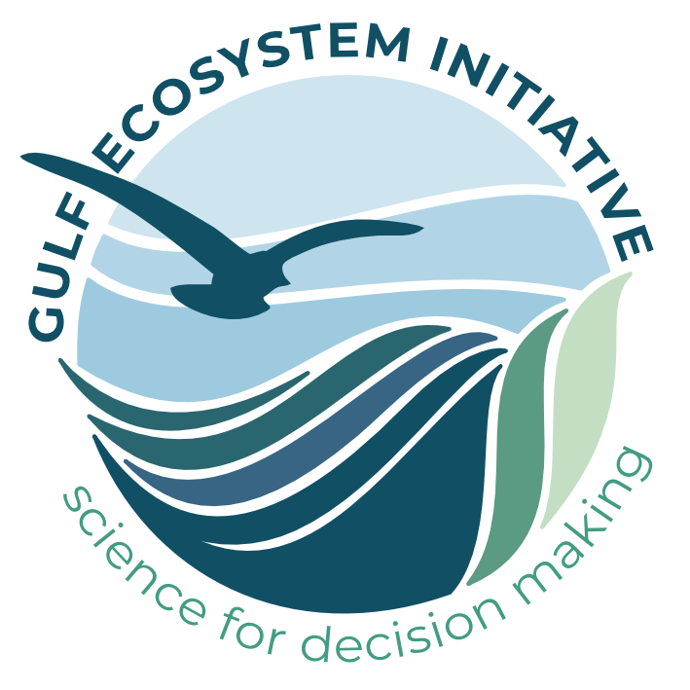
Gulf Ecosystem Initiative: Guidelines for Proposals
The main body of your synthesis working group proposal should be relatively short at 2000 words or less. This word limit excludes various supplementary materials, like Cover Sheet, Figures, two required Tables (Table of Participants, Table of Datasets), Literature Cited, CVs, and Budget. These are all described below. Please follow the formatting and submission instructions provided here, and save and submit your proposal as an MS Word document.
Your proposal should include all of the following:
COVER SHEET (1 page, not included in proposal body word limit)
Date of Submission:
Descriptive Title:
Short Title (2-3 words for use as a project name; 25 characters max):
Working Group Leader(s): name(s), position(s), complete contact information, and indicate primary point of contact
Project Summary (brief scientific abstract of your project; 200 words maximum):
Proposed Project Start and End Dates (month, year):
TABLE OF PARTICIPANTS (See suggested template, not included in proposal body word limit)
Names and affiliations of participants (maximum of 16). Please indicate each person’s project expertise (scientific, analytical, etc.), their expected role or contributions, career stage, and participation status (confirmed, invited but not confirmed or to be invited)
Technical Liaison. Place an asterisk (*) next to a name to indicate the working group’s technical liaison(s); this participant should have analytical expertise and will engage with NCEAS computing staff when necessary, including when archiving the project’s produced data.
Communications Liaison. Place a plus sign (+) next to a name to indicate the working group’s communication liaison(s); this participant should have some communications experience and will engage with NCEAS communications staff when necessary, especially when final research products and outcomes are ready to be released and promoted.
TABLE OF DATA SOURCES (See suggested template, not included in proposal body word limit.)
Brief summary of key datasets to be used in the project (e.g., ecosystem type, taxonomic group, key metrics or processes, time series length, location, number of sites or studies)
Source of the data: include URL/doi when publicly available, and/or a person of contact (data owner)
Status of datasets (for example, still needs to be downloaded/acquired, ‘raw’ datasets are in-hand, some exploration of datasets has been done, extensive harmonization of datasets has already been completed)
List any anticipated legal or practical constraints associated with acquiring, using, and sharing project data
BODY OF PROPOSAL (Not to exceed 2000 words, excluding figures and tables, literature cited)
Problem Statement: Clear and concise statement of what is to be done, why it is important, and how it will be accomplished. Provide a clear rationale for why this research would benefit from NCEAS support.
Proposed Activities: Brief description of methods and why they are appropriate
Description of Data Sources: if not fully described in the Data Sources table (above)
Is this proposal (or a closely aligned proposal) under consideration elsewhere? If so, briefly describe the circumstances.
Anticipated Results: Include description of expected research products & outcomes, data and/or software products, as well as the project’s potential impacts on resource management practices.
Anticipated Benefits: Identify key stakeholder audiences & potential external collaborators for working group outputs with as much specificity as possible, and how they may apply the research outcomes. As space allows, also share context regarding known opportunities or traction for this work, and/or challenges for the application of outcomes
Working group management: Please summarize how the PIs intend to manage the project to support productive and inclusive collaboration. This could include (but is not limited to): methods for communication between in-person meetings, group facilitation, project management tools, plans for occasional virtual meetings. (For sample approaches, see NCEAS Virtual Collaboration resources)
Working Group Diversity: Please provide a brief summary of how you selected working group members in order to achieve a diverse team, and outline how you plan to build and maintain an inclusive working group culture.
Matching Funds: Please outline any potential matching funds your group may be able to bring to this project. Note that matching funds are highly encouraged and are considered in the evaluation process.
BUDGET TEMPLATE (use provided GulfEco RFP Budget worksheet in Excel, and save as its own file in Excel only)
CURRICULUM VITAE for each working group leader: two (2) page maximum, NSF-style biosketch (not included in proposal body word limit)

