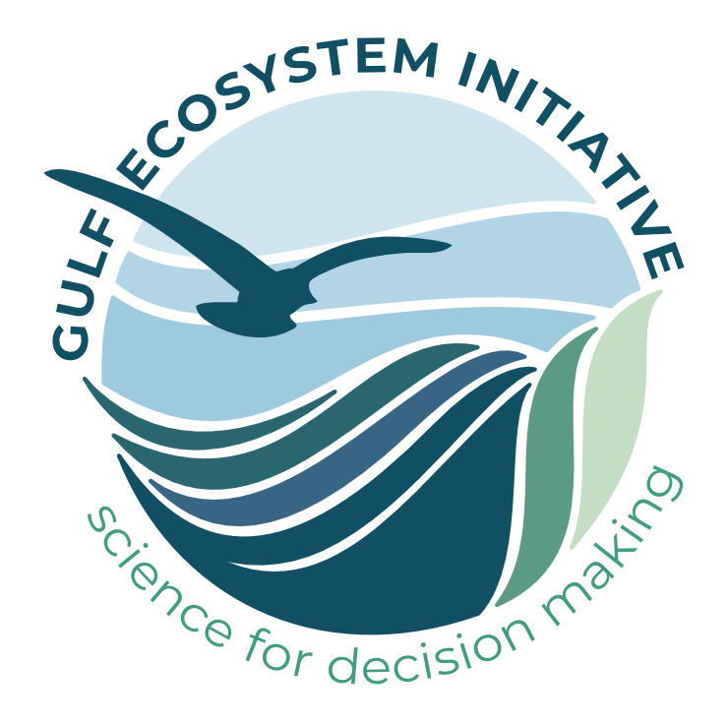
Gulf Ecosystem Initiative
2023 Request for Proposals
Request for Proposals due: January 31, 2023 at 5:00pm, Pacific Time
Website: www.nceas.ucsb.edu/gulfeco
For inquiries email: gulfeco@nceas.ucsb.edu

The Gulf Ecosystem Initiative is a partnership between the National Center for Ecological Analysis and Synthesis (NCEAS) and the NOAA RESTORE Science Program designed to convene scientific working groups consisting of government agency, NGO, tribal, private sector, and academic researchers to synthesize data, science, and knowledge about the Gulf of Mexico. The goal of these working groups is to inform resource management, including restoration. These teams will be supported with training in the cutting-edge data science and management skills that are most relevant to each working group’s near- and long-term challenges. This collaborative approach will advance the skills of professionals working in resource management and stewardship while developing science that can inform solutions to pressing issues facing the Gulf of Mexico.

The Gulf Ecosystem Initiative’s 2023 Request for Proposals asks project teams to propose research that is transdisciplinary and cross-sectoral and, through collaboration and innovation, seeks to tackle pressing scientific and societal challenges focused around three themes in the Gulf of Mexico: fisheries management; climate change; and the ecological impact of management actions.

Fisheries: Applicants to the fisheries priority should use the wealth of long-term fisheries, fish habitat, spawning aggregation, fish recruitment, and environmental datasets to elucidate linkages between various fisheries and related ecosystem drivers. Across the Gulf, fisheries management bodies are engaged with scientific researchers, non-profit organizations, and the commercial and recreational fisheries community to negotiate the complex needs of Gulf fisheries. Synthesis activities should leverage existing partnerships, build new partnerships to address pressing data needs, and tailor resulting synthesis products to stakeholder needs.

Climate Change: Despite numerous studies investigating climate change impacts in the Gulf, we lack an understanding of feedback loops within the system, including how human actions such as oil and gas production, alterations of freshwater and sediment flows, and coastal development will intersect with species migrations, habitat changes, and population dynamics of biologically important resources. Synthesis activities should leverage long term data sets, large climate data sets, and relevant existing downscaled climate modeling to analyze climate change impacts in the GoM and produce an ecosystem perspective that can inform societal response.

Ecological impact of management actions: Proposed synthesis activities may address previous, recurring, or ongoing management actions including restoration actions at any temporal or spatial scale in the Gulf of Mexico. Applicants should utilize existing datasets to produce an understanding of system wide impacts of the management action. Resulting synthesis products should provide an ecosystem-based understanding of the action that can inform similar or related management actions now or in the future.

Each funded project will bring together a working group of 12-16 experts for 2-4 in-person collaborative sessions over the course of 24 months. The working group will conceive new approaches to its respective problem area, synthesize data relevant to the work, develop science in service of relevant solutions, and identify resource management decisions that may be informed by working group products. Between sessions, members will collaborate remotely, participate in NCEAS-provided trainings directly relevant to the research, explore emerging research outcomes, engage with resource managers and other stakeholders, and identify practical opportunities to enhance management activities (e.g. trainings, workshops, communities of practice), and publish research and results. The program emphasizes and provides technical support for repeatable synthesis and modeling methods, and the creation of open-source tools where relevant. Over time, ideas and relationships fostered within each team may influence management policy or practice at local, state, or regional levels and initiate related cross-sectoral action.

As part of the collaboration, NCEAS provides Gulf Ecosystem Initiative teams with state-of-the-art facilities, training expertise, and cyberinfrastructure and logistical support, all informed by its 27 years of experience running innovative and productive transdisciplinary working groups.

Funding
Successful proposals may be awarded $75k - $125k, which is primarily provided to offset working group meeting travel, lodging, and per diem expenses. Funds cannot be used to cover salaries of Principal Investigators (PIs) or other group members. Funded working groups will meet at NCEAS in Santa Barbara, California, where NCEAS provides significant logistical and technical support (note: ongoing Covid-related uncertainty may impose future constraints on travel, however we ask proposers to assume in-person meetings will proceed). Learn more about the working group model and how holding working group meetings in-person at NCEAS has been shown to increase group cohesion, productivity, and impact.

To Apply:
Download the Gulf Ecosystem Initiative proposal template in Microsoft Word and budget worksheet in Excel, and edit and save as separate files. Documents should be formatted to standard letter size (8.5” W by 11” L), with graphics embedded directly within the document, as relevant.

If you have never participated or organized a scientific working group before or have been involved in working groups in the past but would like to work with NCEAS staff to hone your ideas and proposal, we are here to support you through the proposal process. Please reach out to our staff (gulfeco@nceas.ucsb.edu) or sign up for one of our office hours to discuss the proposal process and your unique ideas for a working group.

Submission: Please attach your proposal in Microsoft Word, and your budget worksheet in Excel (other file formats including .ZIP files are not accepted), with the following information listed in the body of an email: PI name(s), first PI email address, first PI’s institutional affiliation, proposal title, full budget amount. Then submit this to gulfeco@nceas.ucsb.edu with the subject line “Gulf Ecosystem Initiative 2022 proposal”.

Proposals are due no later than 5:00pm PDT on January 31, 2023. In the event of a natural disaster or other significant event that may hinder completion of proposals for a considerable group of people, we will post updates to the due date on our website. Late or incomplete submissions will not be reviewed. We will confirm receipt of your proposal by email within 24 hours; if you do not receive a confirmation, please inquire by emailing gulfeco@nceas.ucsb.edu and include the first PI’s name.

Proposal Review: Proposals are evaluated for their scientific merit, novel approaches, and potential to inform transformative solutions to resource management challenges. Proposals are also evaluated for inclusion of appropriate scientific and technical expertise and commitment to diversity and inclusion. The proposal review panel, which includes experts in applied environmental science, may request additional reviews from experts with special relevance to the proposed research. Gulf Ecosystem Initiative leadership makes final proposal selection decisions in consultation with this panel. Based upon panel reviews, program leadership may request proposal modifications (e.g., adjustments to working group size or composition, inclusion of additional data resources) before funding is awarded. All criteria are weighted equally in the review process. Below is a comprehensive list of evaluation criteria:
- Applied research: research question(s) tackle clear resource management challenges in the GoM related to one or more of the three themes
- Urgency: makes clear why question(s) is critically important right now, and how the work will add value both to current state of knowledge and other work underway in the GoM related to one or more of the three themes
- Science in service of solutions: articulates clearly the project’s potential impact pathway and anticipated management and/or policy implications in the GoM related to one or more of the three themes
- Outcomes and results: clearly describes the project’s expected research (and other) outcomes through the funding period, and how those outcomes may inform solutions in the GoM related to one or more of the three themes
- Inclusion: clearly articulates how the team plans to build and maintain an inclusive working group culture
- Diversity: group composition includes confirmed members representing diversity in sectors, disciplines, career stages, backgrounds, and other characteristics
- Efficiency: presents a well-justified argument for cost-effective use of Gulf Ecosystem Initiative funds
- Data availability: the data are known (or likely) to be available
- Applicability: justifies how the proposed methods for synthesis and analysis are poised to make high-impact contributions to science and practical outcomes
- Unique contribution: the research and challenge seem to occupy unique and exciting niche(s) that the Gulf Ecosystem Initiative ought to support

Applicants will be notified of final decisions in May 2023; funded projects should plan to begin project work soon after, and to hold their first working group meeting in Fall 2023.

Key 2022 Proposal Dates and Deadlines
- Informational webinar: Tuesday, November 29, 2022 at 10am PDT/12pm CDT
  - Register here: https://ucsb.zoom.us/webinar/register/WN_QKiVCRJlR3G3guh-2-pOqw
  - Office hours to ask questions one-on-one of NCEAS staff about proposal preparation can be scheduled here
- Proposal due date: Tuesday, January 31, 2023 at 5pm PDT/7pm CDT
- Awards announced: May 2023
- Projects begin: Fall 2023

See the following FAQ section for more detailed information. If you have questions not answered there, please contact The Gulf Ecosystem Initiative at gulfeco@nceas.ucsb.edu.

More information about the Gulf Ecosystem Initiative, and FAQs
The Need
- Solving today’s data-intensive resource management challenges requires transdisciplinary collaboration, the application of advanced tools, and diverse ways of knowing
- Rarely are agency, NGO, tribal, private sector, and academic researchers from diverse disciplines funded to convene, co-develop, and co-execute data-driven environmental science, despite the clear need for this
- Resource managers and researchers hold a vast amount of key environmental data sets, innovative ideas, and opportunities for impactful science to action. Integrating data science learning with hands-on application of skills in the development of synthesis products can make data more usable and research outputs more impactful.

The Opportunity
- The Gulf Ecosystem Initiative accelerates science and builds capacity in the service of management solutions by:
  - Engaging a range of relevant researcher and practitioner expertise in synthesis groups
  - Providing tailored and targeted trainings in reproducible open data science, team science, data management and storage, facilitation, and communication
  - Matching working groups to postdoctoral scholars at NCEAS that can help support and accelerate working group science
- The Gulf Ecosystem Initiative’s annual call for proposals yields 2-3 working groups funded at approximately $75,000 - $125,000 to convene their teams and conduct their work across 2 years
- NCEAS provides training expertise, logistical and cyberinfrastructure support, state-of-the-art facilities, and years of experience running innovative transdisciplinary working groups
- The NCEAS synthesis working group approach produces applied science outcomes that can inform transformative changes to policy and practice, and can help organizations build science capacity while producing innovative, challenge-specific scientific results

NCEAS has been a transformational force in ecology and environmental science since its founding in 1995, and has convened over 400 unique working groups. The working group model, which brings together experts to conduct synthesis science targeted at specific ecological challenges, is proven to effectively and efficiently drive results and inform solutions. This field faces increasing data and management complexities, and we’ve discovered that targeted trainings provided at strategic points during the working group process can greatly accelerate team science, enhance data skillsets among environmental professionals, and provide a more solid foundation for future collaborations.

Diversity Expectations
All proposals must include a brief summary of the process used to achieve a diverse team and outline how the project will maintain an inclusive culture. Working group leaders and team members must agree to the NCEAS Code of Conduct.

Frequently Asked Questions

What is the model of a good working group?
NCEAS has supported synthesis science teams since 1995. Rigorous evaluations of our outcomes have found that effective working groups (WG) tend to include the following:

- A transdisciplinary team of 12-16 individuals from an array of relevant sectors, institutions, and specialties who may not otherwise convene around a specific science or conservation challenge. Scientists, practitioners, other experts and (in some cases) stakeholders will work together from the beginning to design the project and co-produce its analyses, products, and outcomes.
- Members who play different roles, including a) subject matter experts from a range of natural and social sciences, and b) strategy or application experts who can facilitate the translation and integration of knowledge across disciplines for targeted outcomes and thereby help develop decision-relevant products.
- Contributions of individuals from diverse backgrounds, beliefs, and cultures. We encourage proposals and WG participation from people of all cultures, ethnicities, religions, national or regional origins, ages, disability status, sexual orientations, gender identities, military or veteran status, or other status protected by law.
- A willingness to abide by NCEAS’ open science data principles and code of conduct.
- Principal Investigators (PIs, or team leaders) with demonstrable experience and skills leading diverse teams to achieve both scientific and action-oriented objectives (and/or a willingness to learn these skills).
- A trained facilitator to plan and manage the first WG meeting may help the project launch successfully, especially in cases where the working group PIs are new to leading collaborative, transdisciplinary, multi-sector WGs and/or operating their meetings.
- Two to four meetings spread over a 2-year period. Each meeting should be 3-5 days and focused on data analysis (qualitative and quantitative), synthesis of existing data and information, and ongoing development of research products (new strategic approaches, publications, decision support tools, etc.). Meetings are held at NCEAS in Santa Barbara, California, providing meeting room facilities, travel and logistical support, and information technology (IT) support. Collaboration and analysis continue between meetings.
- One designated Technical Liaison to work with NCEAS scientific programming and IT staff on the group’s computing needs, including collaboration capabilities (project management capabilities and email alias), data entry and organization, database development, statistical analyses, modeling, and metadata development and distribution. This could be one of the PIs or another WG member who has agreed to fulfill this role.
- One designated Communications Liaison to work with NCEAS staff on project outreach tasks, including the development of a project webpage and announcements about products and outcomes. This could be a PI or another WG member who has agreed to fulfill this role.

Who is eligible to apply for a Gulf Ecosystem Initiative working group?
Researchers and practitioners of any nationality affiliated with an academic, governmental agency, multilateral, nonprofit, or private institution may submit a proposal. Individuals operating independently are also eligible to apply.

How can Gulf Ecosystem Initiative funds be allocated? Are there limits on the types of activities for contracts? Is there an upper limit on the amount of contracts?
Gulf Ecosystem Initiative funds are provided to convene working groups, cover some research publications costs, and in some cases to support salaries of meeting facilitators or cover other miscellaneous expenses. Gulf Ecosystem Initiative funds may *not* be used to pay salaries (or portions of work time) of PIs or other working group members. See the provided budget worksheet for more information.

How should a diverse team of individuals be included in my working group?
Your group should include a transdisciplinary mix of 12-16 individual experts. This group should include scientists and practitioners from a relevant mix of sectors and institutions; some strategy or application experts who can facilitate the translation and integration of knowledge across disciplines; and individuals with strong connections to decision-makers and potentially related stakeholder groups who can help the group maintain a clear focus on those communities’ needs and expectations.

Members should work together from the beginning of the project to design and co-produce its knowledge products. Gaining strong participation commitments from the outset will help maximize project success, since the group’s proposal and first meeting will set the project research questions and a clear plan for all remaining work.

Working group proposals can include a letter of support from one or more program, agency, or other management entity whose staff may participate in the working group, stating why the working group’s efforts are important and outlining how they may intend to apply the results.

What support, in addition to funding, does the Gulf Ecosystem Initiative provide to funded working groups?
Program staff provide various support throughout the project, including:
- Project management advice, informed by NCEAS’ experience with successful working groups
- Access to relevant NCEAS trainings in team science, data science and management, communications, etc.
- Some data analysis support
- Meeting travel, logistics and reimbursement support
- Contract development support, as appropriate
- Communications and outreach support regarding promotion of the project’s research products

How do I prepare a Gulf Ecosystem Initiative budget?
Proposals must include a completed budget worksheet template (see detailed instructions therein). The worksheet will automatically assist with cost calculations.

The Gulf Ecosystem Initiative does not fund the collection of new primary data. Gulf Ecosystem Initiative funds may not be used to pay salaries of working group PIs or participants or to cover overhead expenses.

What is the Gulf Ecosystem Initiative’s proposal review process and timeline? Will I receive feedback on a rejected proposal?
Proposals that strongly align with the Gulf Ecosystem Initiative’s mission and priorities (as described online and in the RFP) will undergo rigorous scientific review by the Gulf Ecosystem Initiative’s Science Advisory Council. This Council will recommend a handful of projects for funding, and the Gulf Ecosystem Initiative will make funding decisions based on these reviews and recommendations. Proposals that are not selected for funding will receive feedback that summarizes the review of the proposal and recommends changes that could improve the proposal in the future.

