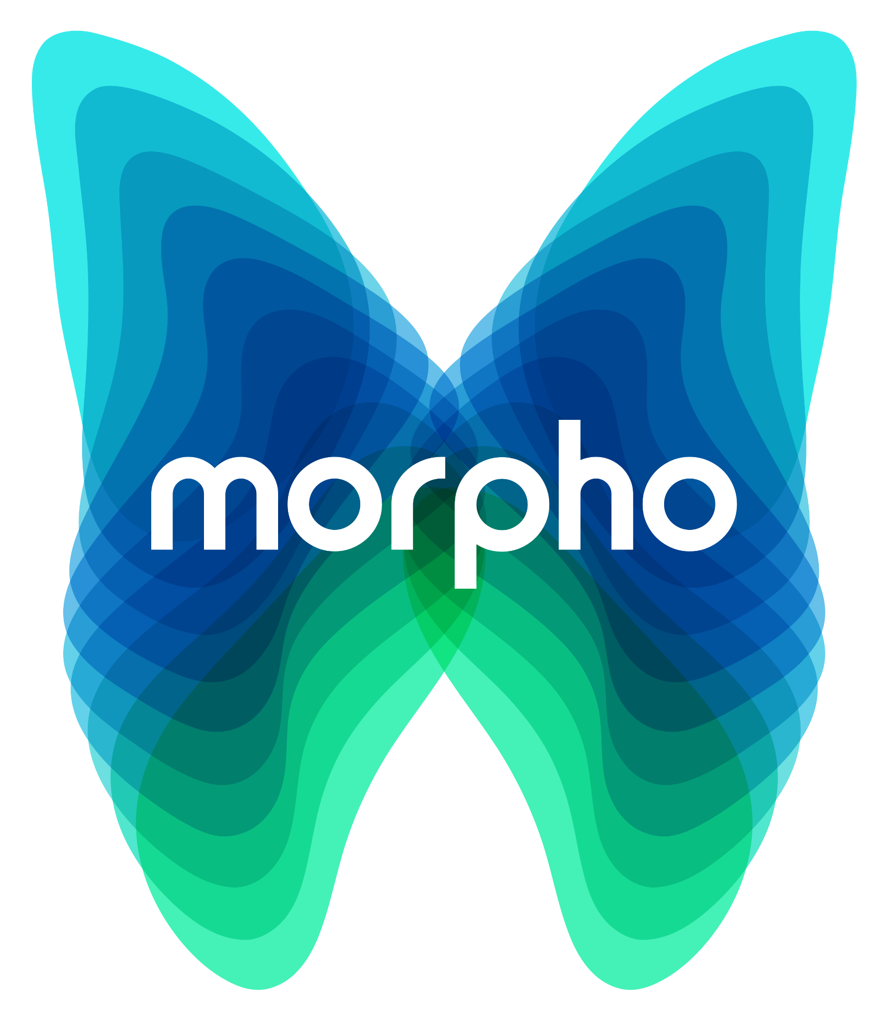

Morpho Initiative:
2024 Request for Proposals
Request for Proposals due date: April 15, 2024 at 5:00pm, Pacific Time
Website: https://www.nceas.ucsb.edu/morpho
For inquiries email: morpho@nceas.ucsb.edu

The Morpho Initiative is an applied environmental science initiative that convenes scientific working groups consisting of government agency, NGO, tribal, and academic researchers to develop and accelerate management-relevant “science in-service-of solutions.” These teams will be enhanced by hands-on training in cutting edge data science and management skills that are most relevant to each working group’s near- and long-term needs. This collaborative approach is geared towards professionals working in environmental management and conservation, and the program thus aims to advance skills while developing science that can inform solutions to pressing issues facing our changing planet.

The Morpho Initiative’s Annual Request for Proposals asks potential team leaders to articulate and propose a research opportunity for transdisciplinary and cross-sectoral collaboration and innovation to influence management action or practice. Each funded project will bring together a working group of 12-15 experts for 3-4 in-person collaborative sessions over the course of 24 months. The working group will conceive new approaches to its respective problem area, synthesize data relevant to the work, and develop science in service of relevant solutions. Between sessions, members will collaborate remotely, participate in Morpho-provided trainings directly relevant to the research, explore emerging research outcomes, identify practical opportunities to enhance management activities, and publish research and results. Over time, ideas and relationships fostered within Morpho teams may influence management policy or practice at local, state, national or international levels and initiate related cross-sectoral action.

The Morpho Initiative is a program of the National Center for Ecological Analysis and Synthesis (NCEAS) at the University of California, Santa Barbara. NCEAS provides Morpho teams with state-of-the-art facilities, training expertise, and cyberinfrastructure and logistical support, all informed by its nearly thirty years of experience running innovative and productive transdisciplinary working groups.

Working Group Funding
Successful working group proposals may be awarded up to $125k, which is primarily provided to offset working group meeting travel, lodging, and per diem expenses. Funds cannot be used to cover salaries of Principal Investigators (PIs) or other group members. Funded working groups will meet at NCEAS in Santa Barbara, California, where Morpho provides significant logistical and technical support. Working groups that can bring matching funds that cover participant costs (e.g., travel) to their projects are strongly encouraged to do so; if relevant, please indicate details in the body of the proposal.

To Apply for a Working Group:
Download the Morpho proposal template in Microsoft Word and budget worksheet in Excel, and edit and save as separate files in these respective programs. Documents should be formatted to standard letter size (8.5” W by 11” L), with graphics embedded directly within as relevant.

Submission: Please fill out the submission form and then email your proposal materials to morpho@nceas.ucsb.edu with the subject line “Morpho 2024 proposal_Lead PI last name”. The submission should be in MS Word, and your budget worksheet in Excel (other file formats including .ZIP files are not accepted).

Proposals are due no later than 5:00pm PDT on April 15, 2024. Late or incomplete submissions will not be reviewed. We will confirm receipt of your proposal by email within 24 hours; if you do not receive a confirmation, please inquire by emailing morpho@nceas.ucsb.edu and include the first PI’s name.

Proposal Review: Proposals are evaluated for their scientific merit, novel approaches, and potential to inform transformative solutions to environmental problems. Proposals are also evaluated for inclusion of appropriate scientific and technical expertise, commitment to diversity and inclusion, and potential matching funds. The proposal review panel includes experts in applied environmental science, which may request additional reviews from experts with special relevance to the proposed research. Morpho leadership makes final proposal selection decisions in consultation with this panel. Based upon panel reviews, Morpho may request proposal modifications (e.g., adjustments to working group size or composition, inclusion of additional data resources) before funding is awarded. All criteria are weighted equally in the review process. Below is a comprehensive list of evaluation criteria:
- Applied research: research question(s) tackle clear resource management challenges
- Urgency: makes clear why question(s) is critically important right now, and how the work will add value both to current state of knowledge and other work underway
- Science in service of solutions: articulates clearly the project’s potential impact pathway and anticipated management and/or policy implications
- Outcomes and results: clearly describes the project’s expected research (and other) outcomes through the funding period, and how those outcomes may inform solutions
- Inclusion: clearly articulates how the team plans to build and maintain an inclusive working group culture
- Diversity: group composition includes confirmed members representing diversity in sectors, disciplines, career stages, backgrounds, and other characteristics
- Efficiency: presents a well-justified argument for cost-effective use of Morpho funds
- Data availability: the data are known (or likely) to be available
- Applicability: justifies how the proposed methods for synthesis and analysis are poised to make high-impact contributions to science and practical outcomes
- Unique contribution: the research and challenge seem to occupy unique and exciting niche(s) that the Morpho ought to support

Applicants will be notified of final decisions in June 2024; funded projects should plan to begin project work soon after, and to hold their first working group meeting in Fall 2024 or early 2025.

Key 2024 Proposal Dates and Deadlines
- Informational webinar: Wednesday, February 28, 10am PST (Register here)
- Informational office hours: Wednesdays 11am-12pm PT (link to reserve a time)
- Proposal due date: Thursday April 15, 5pm PDT
- Awards announced: June 2024
- Projects begin: Fall 2024

See the following FAQ section for more detailed information. If you have questions not answered there, please contact Morpho at morpho@nceas.ucsb.edu.

More information about the Morpho Initiative, and FAQs
The Need
- Solving today’s data-intensive environmental challenges requires transdisciplinary collaboration, the application of advanced tools, and diverse ways of knowing.
- Rarely are agency, NGO, tribal and academic researchers from diverse disciplines funded to convene, co-develop and co-execute data-driven environmental science, despite the clear need for this.
- Resource managers and researchers hold a vast amount of key environmental data sets, innovative ideas, and opportunities for impactful science to action. Integrating data science learning with hands-on application of skills in the development of synthesis products can make data more usable and research outputs more impactful.

The Opportunity
- Morpho accelerates science and builds capacity in the service of management solutions by:
  - Engaging a range of relevant researcher and practitioner expertise in synthesis groups
  - Providing tailored and targeted trainings in reproducible open data science, team science, data management and storage, facilitation, and communication
  - Leveraging matching funds to extend project impact
- Morpho’s 2024 call for proposals supports 1-2 working groups with up to $125,000 in funding to convene their teams and conduct their work across 2-years
- NCEAS provides training expertise, logistical and cyberinfrastructure support, state-of-the-art facilities, and years of experience running innovative transdisciplinary working groups
- The NCEAS synthesis working group approach produces applied science outcomes that can inform transformative changes to policy and practice, and can help organizations build science capacity while producing innovative, challenge-specific scientific results

NCEAS has been a transformational force in ecology and environmental science since its founding in 1995, and has convened over 400 unique working groups. The working group model, which brings together experts to conduct synthesis science targeted at specific ecological challenges, is proven to effectively and efficiently drive results and inform solutions. This field faces increasing data and management complexities, and we’ve discovered that targeted trainings provided at strategic points during the working group process can greatly accelerate team science, enhance data skillsets among environmental professionals, and provide a more solid foundation for future collaborations.

Diversity Expectations
All proposals must include a brief summary of the process used to achieve a diverse team and outline how the project will maintain an inclusive culture. Working group leaders and team members must agree to the NCEAS Code of Conduct.

Frequently Asked Questions

What is the model of a good working group?
NCEAS has supported synthesis science teams since 1995. Rigorous evaluations of our outcomes have found that effective working groups (WG) tend to include the following:

- A transdisciplinary team of 12-15 individuals from an array of relevant sectors, institutions, and specialties who may not otherwise convene around a specific science or conservation challenge. Scientists, practitioners, other experts and (in some cases) stakeholders will work together from the beginning to design the project and co-produce its analyses, products and outcomes.
- Members who play different roles, including a) subject matter experts from a range of natural and social sciences, and b) strategy or application experts who can facilitate the translation and integration of knowledge across disciplines for targeted outcomes and thereby help develop decision-relevant products
- Contributions of individuals from diverse backgrounds, beliefs and cultures. We encourage proposals and WG participation from people of all cultures, ethnicities, religions, national or regional origins, ages, disability status, sexual orientations, gender identities, military or veteran status or other status protected by law.
- A willingness to abide by NCEAS’ open science data principles and code of conduct
- Principal Investigators (PIs, or team leaders) with demonstrable experience and skills leading diverse teams to achieve both scientific and action-oriented objectives (and/or a willingness to learn these skills)
- A trained facilitator to plan and manage the first WG meeting may help the project launch successfully, especially in cases where the working group PIs are new to leading collaborative, transdisciplinary, multi-sector WGs and/or operating their meetings
- Three to four meetings spread over a 2-year period. Each meeting should be 3-5 days and focused on data analysis (qualitative and quantitative), synthesis of existing data and information, and ongoing development of research products (new strategic approaches, publications, decision support tools, etc.). Meetings are held at NCEAS in Santa Barbara, California, where Morpho provides meeting room facilities, travel and logistical support, and information technology (IT) support. Collaboration and analysis continue between meetings.
- One designated Technical Liaison to work with Morpho scientific programming and IT staff on the group’s computing needs, including collaboration capabilities (project management capabilities and email alias), data entry and organization, database development, statistical analyses, modeling, and metadata development and distribution. This could be one of the PIs or another WG member who has agreed to fulfill this role.
- One designated Communications Liaison to work with Morpho staff on project outreach tasks, including the development of a project webpage and announcements about products and outcomes. This could be a PI or another WG member who has agreed to fulfill this role.

Who is eligible to apply for a Morpho Initiative working group?
Researchers and practitioners of any nationality affiliated with an academic, governmental agency, multilateral, or nonprofit institution may submit a proposal. Individuals operating independently are also eligible to apply.

How can Morpho Initiative funds be allocated? Are there limits on the types of activities for contracts? Is there an upper limit on the amount of contracts?
Morpho funds are provided to convene working groups, cover some research publications costs, and in some cases to support salaries of meeting facilitators or cover other miscellaneous expenses. Morpho funds may *not* be used to pay salaries (or portions of work time) of PIs or other working group members. See the provided Morpho budget worksheet for more information.

How should a diverse team of individuals be included in my working group?
Your group should include a transdisciplinary mix of 12-15 individual experts. This group should include scientists and practitioners from a relevant mix of sectors and institutions; some strategy or application experts who can facilitate the translation and integration of knowledge across disciplines; and individuals with strong connections to the target audience (decision-makers and potentially related stakeholder groups), who can help the group maintain a clear focus on those communities’ needs and expectations.

Members should work together from the beginning of the project to design and co-produce its knowledge products. Gaining strong participation commitments from the outset will help maximize project success, since the group’s proposal and first meeting will set the project research questions and a clear plan for all remaining work.

Working group proposals can include a letter of support from one or more programs, agencies, or other management groups whose staff may participate in the working group, stating why the working group’s efforts are important and outlining how they may intend to apply the results.

What support, in addition to funding, does the Morpho Initiative provide to funded working groups?
Morpho staff and program representatives provide various support throughout the project, including:
- Project management advice, informed by NCEAS’ experience with successful working groups
- Access to relevant NCEAS trainings in team science, data science and management, etc
- Meeting travel, logistics and reimbursement support
- Communications and outreach support

How do I prepare a Morpho Initiative budget?
Proposals must include a completed budget worksheet template (see detailed instructions therein). The worksheet will automatically assist with cost calculations.

Morpho does not fund the collection of new primary data. Morpho funds may not be used to pay salaries of working group PIs or participants or to cover overhead expenses.

Are matching sources of funding required for a successful application?
Matching sources are not required but are strongly encouraged; proposals that have secured funding to offset participant costs (e.g. travel) in addition to Morpho funding may be given preferential consideration in the proposal review process.

Partners (e.g., agencies, foundations, non-governmental organizations) that have already identified full project funding elsewhere may request to use Morpho’s neutral space, intellectual infrastructure and NCEAS informatics and convening support to tackle Morpho-relevant projects. These proposals can be flexible in format and can be submitted anytime.

What is Morpho’s proposal review process and timeline? Will I receive feedback on a rejected proposal?
Proposals that strongly align with Morpho’s mission and priorities (as described online and in the RFP) will undergo rigorous scientific review by Morpho’s Science Advisory Council. This Council will recommend a handful of projects for funding, and Morpho will make funding decisions based on these reviews and recommendations.

Limitations in staff time prevent Morpho from providing lengthy feedback to declined proposals, but Morpho may share limited feedback (usually summarized bullet points) about these proposals.

